8.6

Markets short squeeze.

First tick didn’t work.

Can’t expect first tick to work every day. Last week it worked 5/5 and this week 1/2 so far.

Today intraday MA trader should have added position at low.

Long run: cut A share exposure, move assets offshore, if you want, invest in A shares through connect.

Today corrected no trading at 11:30-13:00 (put that in process main)

Sold a few units during noon which were wasted.

Main traders:

1. First tick (real sentiment)
2. Percentile MA (2 day ma)
3. Intraday MA (1 day ma)
4. First tick accu – keep add to first tick pos (pay attention to when this doesn't work and results in oversized position)
5. FutOpen – follow fut sentiment at open

8/9

Markets are highly volatile -> trend following strategy.

High/low trader.

Markets are at the bottom of a range, struggling to get back up,

With very high volatility, you need

Most effective way to hedge when markets are highly volatile, directional

Hedge-on/hedge-off method,

8/10

Friday, August 10, 2018

1. Hilo was trading too much at open, and only 1 direction was traded, 6 orders of 3 lots each, reason is opening volatility, need to put time constraint (FIX: 60 seconds between each trade). Also, it is limited by pmchy, which means only 1 direction can be traded. Use pmchy+percentile to determine size. HiLo is meant to hedge, there is no chasing.
2. Should only be 1 trade at open, time constraint is necessary
3. FirstTick is the first trade, hilo is the second trade, then wait 1 min at least before all other trades.
4. Firsttick was wrong. There was a lag (system used wrong value for first tick ). Don't use last value, use first value that is diff from 9:28 value.
5. Use 2daypercentile and pmchy to determine size, trade all strategies at small size just to see first

8/10/18

Weekly review:

Stocks : +38k. bullish on tues and thurs.

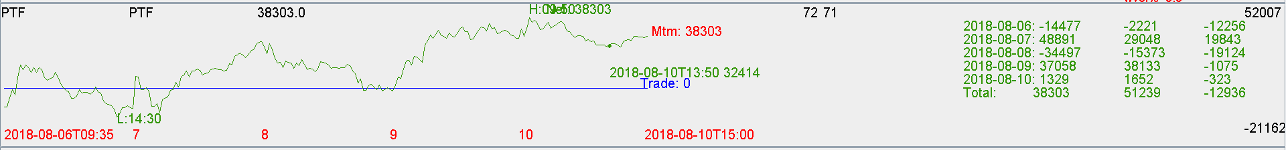

Future:

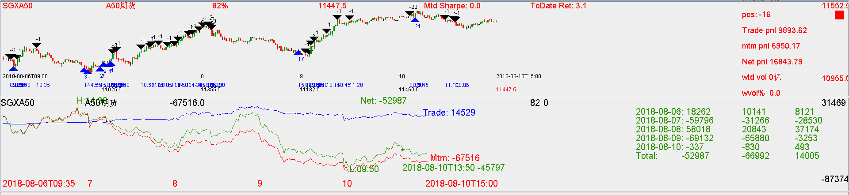

Mtm was negative, but trade was ok, saved some pnl.

Improvements:

1. Thursday morning when there was break higher -> need to trade chinaHiLo
2. Friday morning chinaHiLo there was a mistake (20 lots cancellation, bad)
3. Tue buying was good, all due to fut open buying. Also use chinaHiLo to buy.
4. Monday PM covering was done by percentileMA ( good )